The Committee of Adjustment for the Township of Guelph/Eramosa will be holding a public hearing to consider an application under Section 45 of the Planning Act R.S.O., 1990, P.13, as amended.
NOTICE OF HEARING
Committee of Adjustment Hearings will continue to be held virtually.
Members of the public are encouraged to attend either by telephone or video.
Download the Zoom app to access the virtual meeting using your smart phone device or use the following link to download “Zoom Client for Meetings” to access the meeting using your PC or laptop: https://zoom.us/download#client_4meeting. To call-in over the phone, please follow the directions below. Your phone or computer will be muted upon entering the hearing.

DATE & TIME: Wednesday, October 26th, 2022, at 2:00p.m.
LOCATION: This Public Hearing will be held virtually via ZOOM.

APPLICATION: A13-22

Location of  Property: | 160 Guelph Street, Rockwood, Township of Guelph/Eramosa  PLAN 150 LOTS 6-7 PT LOT 8; NS GUELPH LOTS 14 & 23 PT;  LOT 13 SS ALMA
Purpose: | The applicant is requesting the following:  - To permit a minimum lot area of 4,817.4m², whereas 5,400m² is required  - To permit a minimum exterior side yard setback of 3.5m, whereas 4.5m is required  - To permit a minimum rear yard setback of 4m, whereas 7.5m is required  - To permit a parking ratio of 0.86 spaces per unit, whereas 1.5 spaces per unit is required for off-street parking to permit a total of 43 parking stalls  - To permit a parking area to be located in the front and side yard, whereas the parking area for a residential use containing three or more dwelling units shall only be located within the rear yard.  - To permit a loading space within 13m of the street line, whereas 20m is required.
Request: | Relief from Section 11.2.9, 5.1, 5.1.10.2, 5.3.4 of Zoning By-law 40/2016.
How Do I Provide Comment, Participate or Listen to the Public Hearing?

To Delegate: | To pre-register as a delegate (to speak or make comments), email aroger@get.on.ca. Delegates will be provided with instructions on how to speak during the hearing.
To Listen: | Click this URL to join from a PC, Mac, iPad, iPhone or Android device:  https://us02web.zoom.us/j/88314519164?pwd=M3RNSm9PMmthSE9zM2hjeVRpcHh3QT09  To join by telephone: +1 647 558 0588  Webinar ID:  883 1451 9164  Passcode: 809912
In Writing: | Written comments on the application may be forwarded in person or by mail to the Secretary-Treasurer of the Committee of Adjustment as indicated below.
How Do I Get More Information?
For more information regarding this application, please contact the undersigned:

Amanda Roger, Secretary-Treasurer, Committee of Adjustment
Township of Guelph/Eramosa, 8348 Wellington Rd 124, P.O. Box 700, Rockwood, ON N0B 2K0
Email: aroger@get.on.ca Telephone: 519-856-9596 Ext. 112 Fax (519) 856-2240
How to receive Notification of the Decision? |  | You must make a written request to be circulated on the Notice of Decision to the Secretary-Treasurer of the Committee of Adjustment.

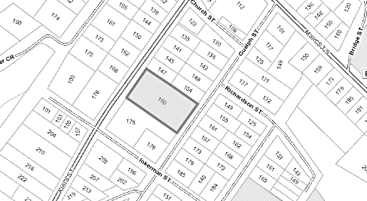
A sketch of the property is included.

Dated at the Township of
Guelph/Eramosa

This 13th day of October 2022

_____________________________
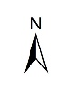
Amanda Roger, Secretary-Treasurer
Subject Property

